**Collaboration between School of Dentistry, University of Birmingham, UK**

**and**

**Sri Guru Ram Das Institute of Dental Sciences and Research, Punjab, India.**

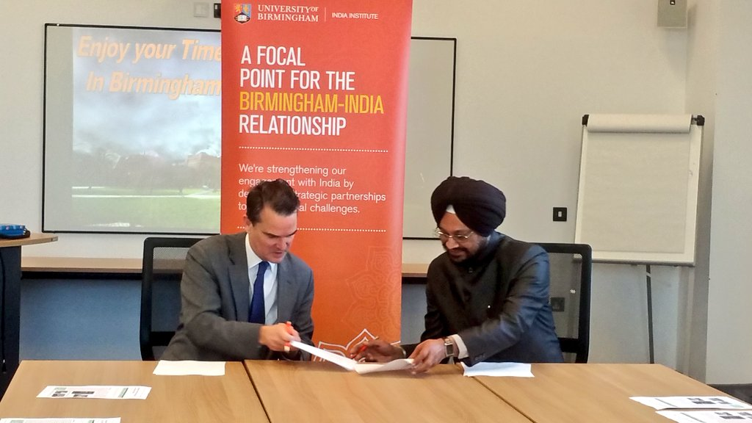

**Signing of MoU at the India Institute, by Dr. Kavipal Singh, Principal, SGRD and Professor Robin Mason, Director, India Institute,**

**University of Birmingham**

On 12th February, 2020, a Memorandum of Understanding was signed between Sri Guru Ram Dass Institute of Dental Sciences & Research (SGRD), Punjab, India and the School of Dentistry, University of Birmingham (UoB), United Kingdom, as part of the collaborations taking place between India and UK in the healthcare sector. It is aimed at promoting exchange of students, staff and of best practices, to develop understanding of research and education between the two institutions.

UoB and SGRD have collaborated to foster exchange of students and staff mutually for short period of time, to work together to promote dental sciences and practical applications of the findings in India, UK and globally, which will enable them to gain foreign expertise and exposure. The two institutions will seek methods of cooperation that will be mutually beneficial.